CS 255 System Design Document Brian Minor

UML Diagrams

UML Use Case Diagram
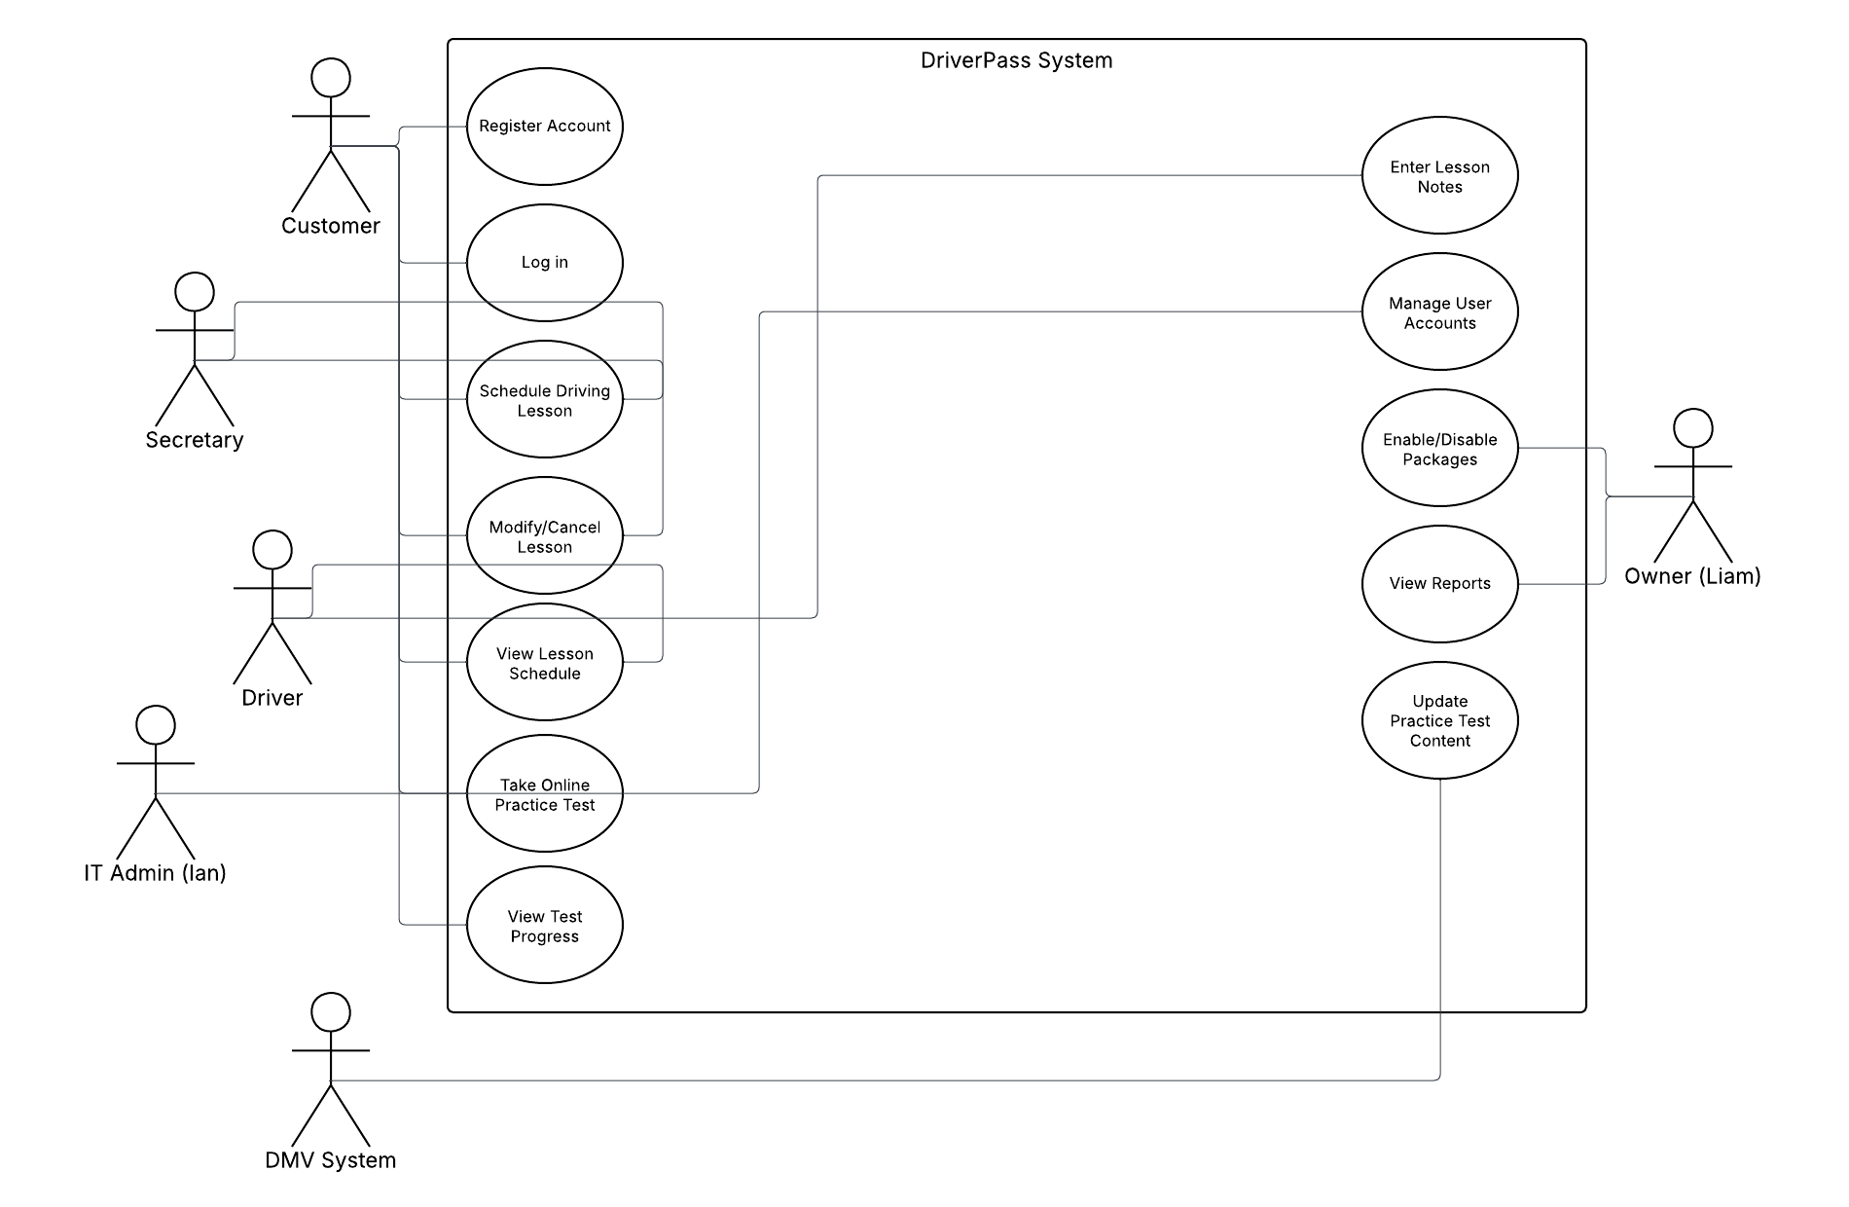

Actors:
- Customer (Student)
- Secretary
- Owner (Liam)
- IT Admin (Ian)
- Driver
- DMV System (external)
Use Cases inside the “DriverPass System” boundary:
- Register Account – Customer creates a new account.
- Log In – All user roles authenticate.
- Schedule Driving Lesson – Customer schedules a 2-hour lesson.
- Modify/Cancel Lesson – Customer or secretary changes or cancels a lesson.
- View Lesson Schedule – Customer and driver view upcoming lessons.
- Take Online Practice Test – Customer completes tests for DMV preparation.
- View Test Progress – Customer checks test history, scores, and status.
- Enter Lesson Notes – Driver records comments after lessons.
- Manage User Accounts – IT Admin manages accounts and resets passwords.
- Enable/Disable Packages – Owner turns lesson packages on or off.
- View Reports – Owner views activity and performance reports.
- Update Practice Test Content – DMV System updates test questions/rules.
Associations:
- Customer ↔ Register Account, Log In, Schedule Lesson, Modify/Cancel Lesson, Take Online Practice Test, View Test Progress, View Lesson Schedule
- Secretary ↔ Schedule Lesson, Modify/Cancel Lesson
- Driver ↔ View Lesson Schedule, Enter Lesson Notes
- IT Admin ↔ Manage User Accounts
- Owner ↔ Enable/Disable Packages, View Reports
- DMV System ↔ Update Practice Test Content

UML Activity Diagrams
Activity Diagram 1 – Schedule Driving Lesson (Customer)
Main flow (activities and decisions):
- Start
- Customer logs in
- System validates credentials
- System displays dashboard
- Customer selects “Schedule Lesson”
- System displays available time slots
- Customer selects date and time
- System checks driver and car availability (Decision)
  - If slot available:
9. System assigns driver and car
10. System saves reservation
11. System sends confirmation (email/text)
12. Customer views updated schedule
13. End
  - If no availability:
9. System displays “slot unavailable” message
10. Customer chooses a different time → back to “Customer selects date and time”

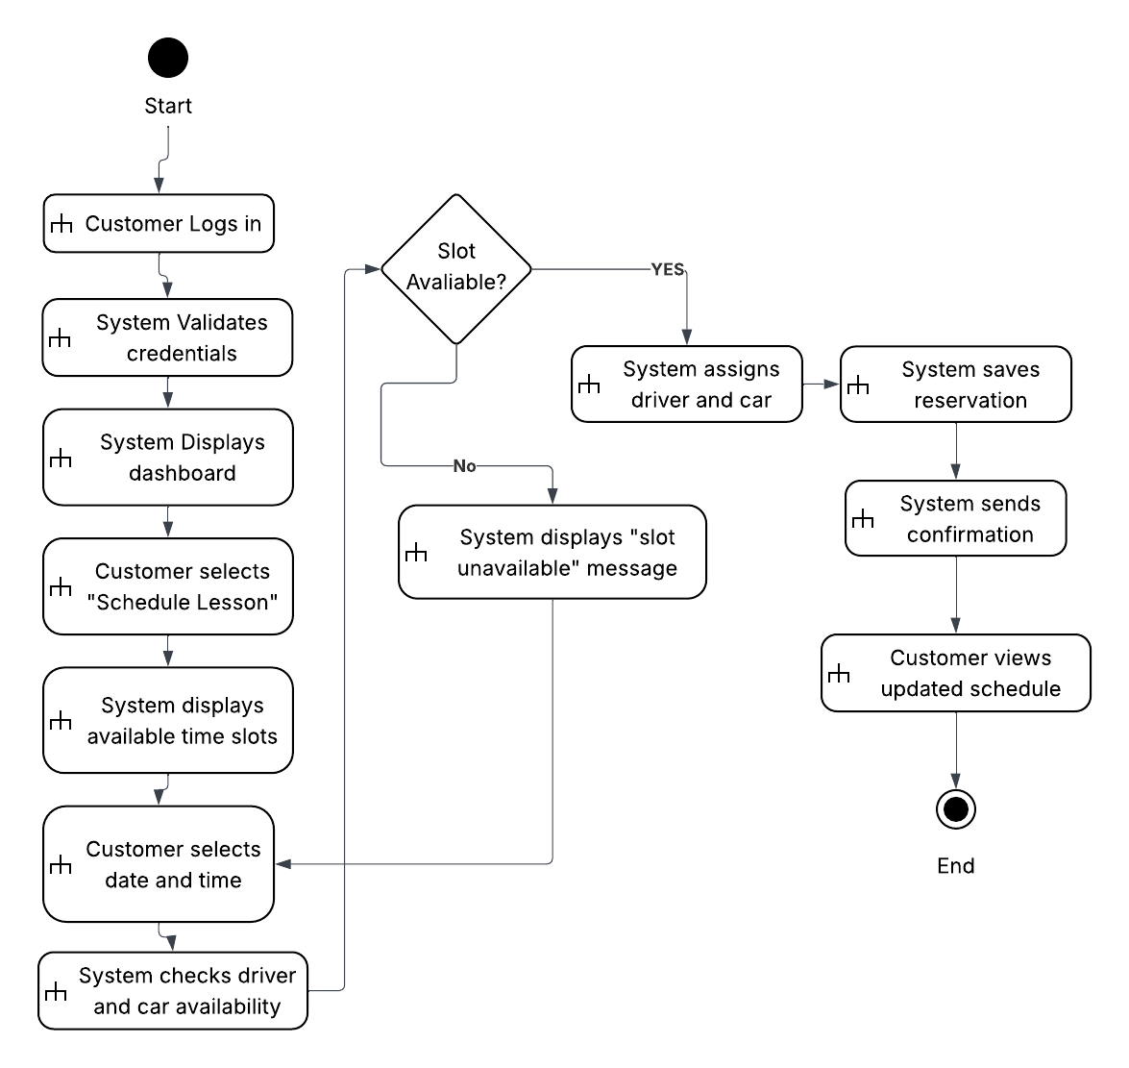

Activity Diagram 2 – Take Online Practice Test
Main flow:
- Start
- Customer logs in
- System validates credentials
- Customer selects “Online Practice Tests”
- System displays available tests
- Customer selects a test
- System loads test questions
- Loop over questions:
  - System displays question
  - Customer submits answer
  - System records answer
  - More questions? (Decision)
    - Yes → back to System displays question
    - No → continue
- System calculates score
- System determines pass/fail status
- System updates test history and progress
- System displays score and status to customer
- End

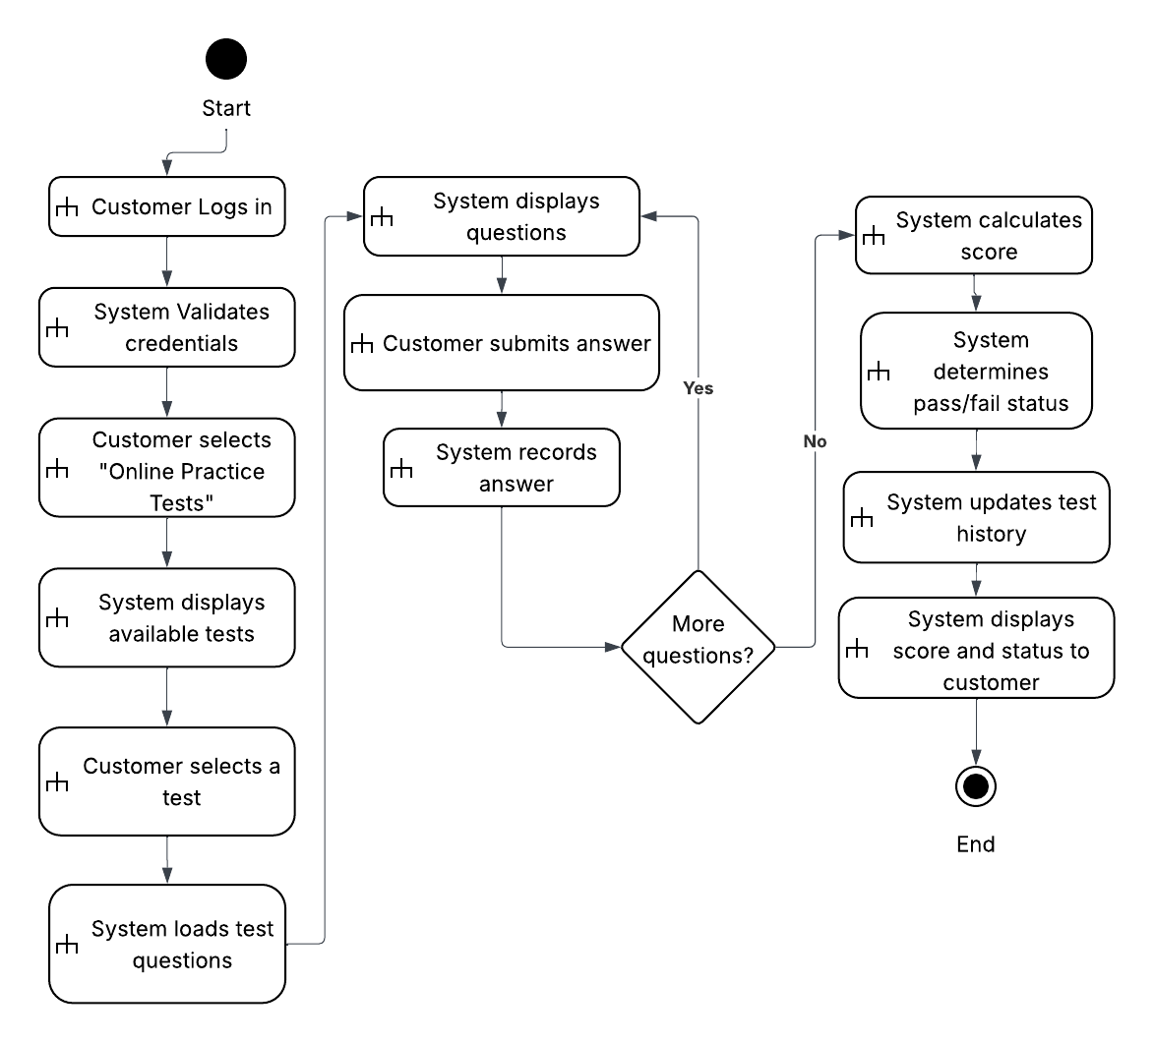

UML Sequence Diagram
Lifelines:
- Customer
- Web Browser / UI
- Scheduling Controller
- Availability Service
- Database
- Notification Service
Message flow:
- Customer → Web UI: “Log in with username/password”
- Web UI → Scheduling Controller: validateCredentials()
- Scheduling Controller → Database: getUser(credentials)
- Database → Scheduling Controller: user record / invalid
- Scheduling Controller → Web UI: “Login success” and dashboard
- Customer → Web UI: “Schedule Lesson”
- Web UI → Scheduling Controller: requestAvailableSlots(customerId)
- Scheduling Controller → Availability Service: checkSlots(customerId)
- Availability Service → Database: querySchedule(drivers, cars, times)
- Database → Availability Service: available time slots
- Availability Service → Scheduling Controller: slot list
- Scheduling Controller → Web UI: show time slots
- Customer → Web UI: select date/time
- Web UI → Scheduling Controller: bookLesson(customerId, dateTime)
- Scheduling Controller → Availability Service: confirmAvailability(customerId, dateTime)
- Availability Service → Database: reserveSlot(driver, car, dateTime, customerId)
- Database → Availability Service: confirmation
- Availability Service → Scheduling Controller: “Reservation successful”
- Scheduling Controller → Notification Service: sendConfirmation(customerContact, lessonDetails)
- Notification Service → Customer: confirmation email/text
- Scheduling Controller → Web UI: “Booking confirmed” + updated schedule

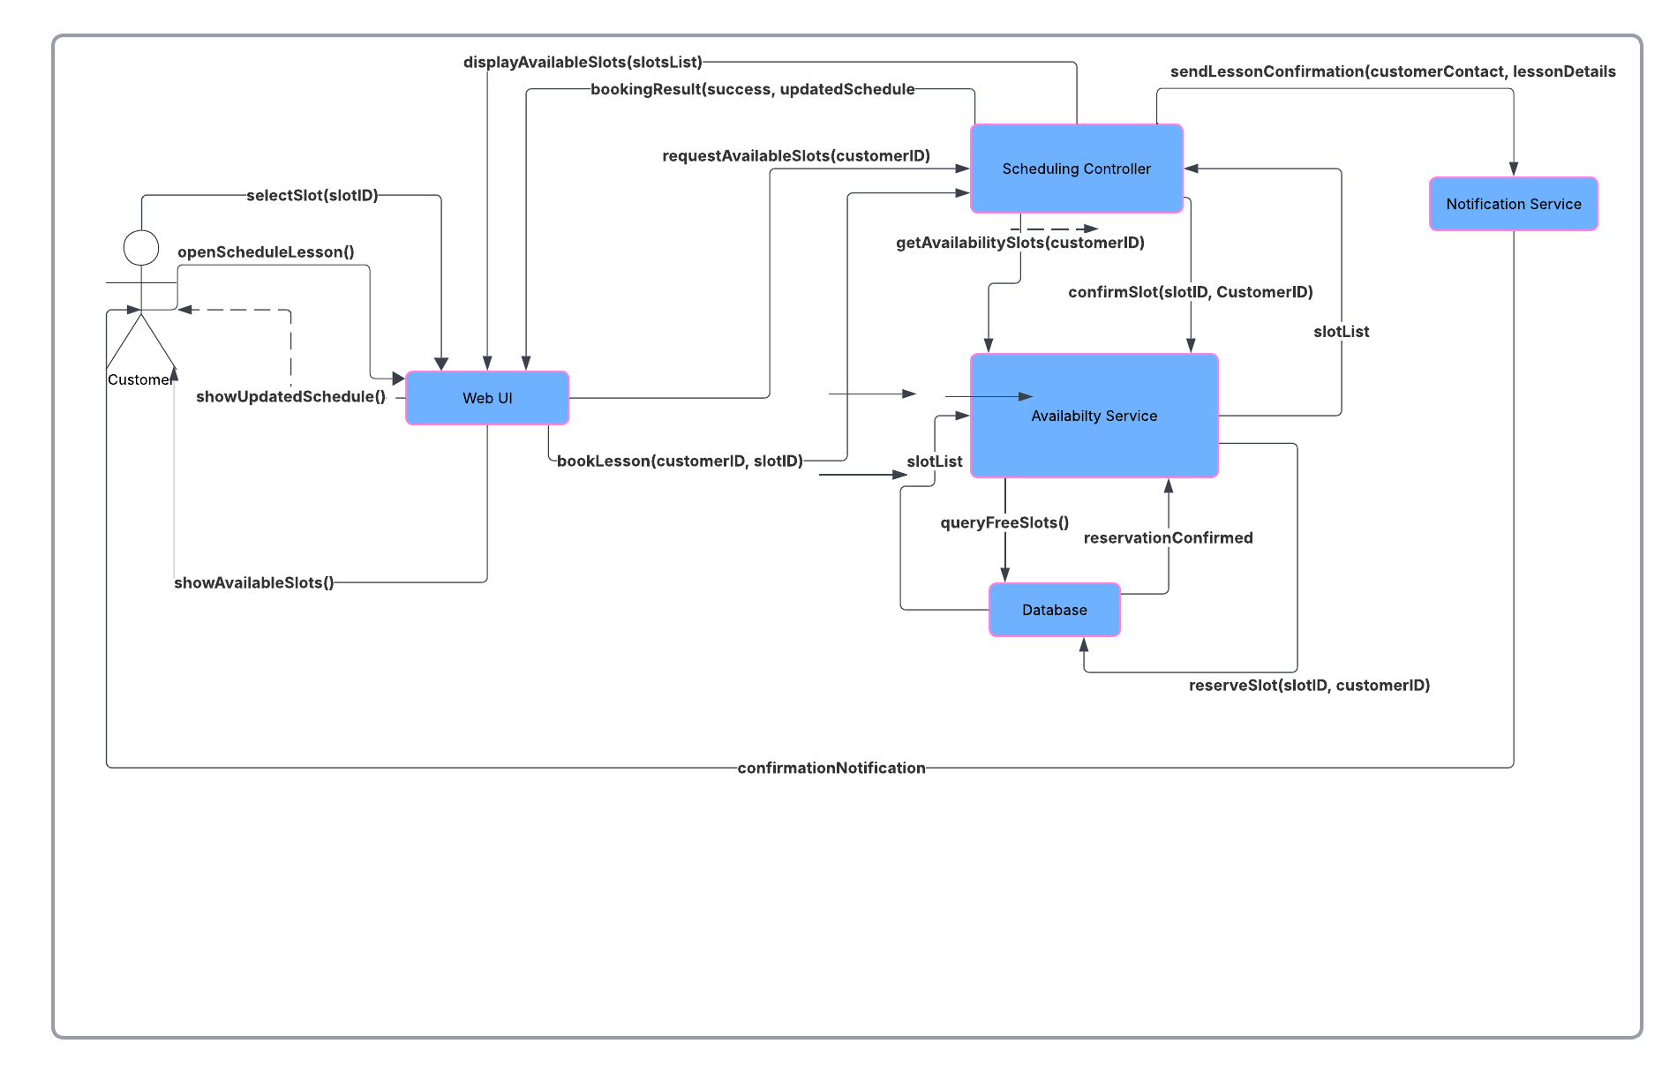

UML Class Diagram
Customer
- customerID
- firstName
- lastName
- address
- phoneNumber
- email
- username
- passwordHash
- pickupLocation
- dropoffLocation
Lesson
- lessonID
- date
- startTime
- endTime
- status (Scheduled, Completed, Canceled)
- pickupLocation
- dropoffLocation
Driver
- driverID
- firstName
- lastName
- licenseNumber
- status
Vehicle
- vehicleID
- make
- model
- plateNumber
- status
Package
- packageID
- name (e.g., “Package One”)
- description
- totalHours
- includesOnlineClass (bool)
- includesInPersonClass (bool)
- isActive
OnlineTest
- testID
- name
- description
- totalQuestions
- passingScore
TestAttempt
- attemptID
- dateTaken
- score
- status (Passed/Failed)
- duration
UserAccount
- userID
- username
- passwordHash
- role (Customer, Secretary, Owner, ITAdmin, Driver)
- isLocked
DMVUpdate
- updateID
- updateType
- description
- effectiveDate
- dateReceived
Key Associations (with multiplicities):
- Customer 1.. Lesson* – A customer can have many lessons; each lesson belongs to one customer.
- Driver 1.. Lesson* – A driver can conduct many lessons; each lesson has one driver.
- Vehicle 1.. Lesson* – A vehicle can be used in many lessons; each lesson uses one vehicle.
- Customer 1.. TestAttempt* – A customer can have many test attempts.
- OnlineTest 1.. TestAttempt* – Each test attempt references one online test.
- Customer 1.. Package* (or via a linking class like CustomerPackage if you want to be more formal).
- UserAccount 1..1 Customer/Driver/Staff depending on role (you can represent this with associations or notes).
- DMVUpdate – Related to OnlineTest (e.g., DMVUpdate 1..* OnlineTest or just a note that updates impact test content).

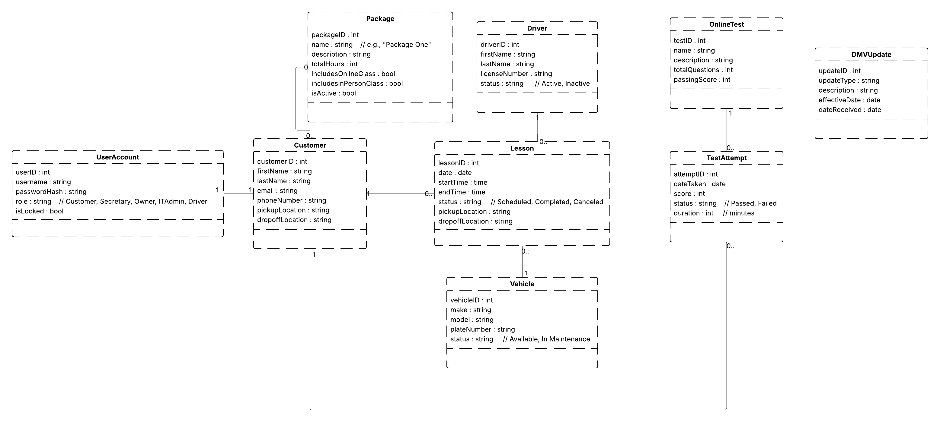

Technical Requirements
Hardware Requirements
- Server-side (cloud hosted):
  - At least one virtual application server hosts the web application.
  - One managed database instance (relational DB such as MySQL or PostgreSQL).
  - Storage for user data, logs, and DMV updates.
- Client-side:
  - Any modern desktop, laptop, tablet, or smartphone with an internet connection.
  - Screen resolution is suitable for web browsing.
Software Requirements
- Server operating system: Any supported OS (for example, Linux on the cloud host).
- Web server software: Standard HTTP server (for example, Apache, Nginx, or a built-in app server).
- Database management system: Relational DB (e.g., MySQL, PostgreSQL, or a comparable cloud database).
- Application stack: A web framework that supports MVC or similar structure (for example, Java/Spring, .NET, or Node.js/Express).
- Security: TLS/SSL certificates for HTTPS encryption.
- Browser support: Latest versions of Chrome, Firefox, Edge, and Safari.
Tools and Development Environment
- CASE tool: Lucidchart for creating UML diagrams.
CS 255 System Design Document T…
- IDE/code editor: Any standard IDE (Visual Studio Code, IntelliJ, Visual Studio, etc.).
- Version control: Git or similar to manage source code.
- Issue tracking: A ticketing or task management system for bugs and features.
Network and Infrastructure Requirements
- Reliable internet connectivity and sufficient bandwidth between client devices and the cloud host.
- HTTPS enforced for all communications between clients and the DriverPass system.
- Firewall and basic network security configurations at the cloud provider level.
- Regular backups of the database and configuration data.
- Logging and monitoring tools to track performance, errors, and security events.
Other Technical Considerations
- Role-based authorization must be implemented so only authorized roles can perform sensitive operations like account management, package control, and viewing reports.
- The system should follow a layered architecture, separating user interface, business logic, and data access.
- The design must support future scalability to handle more students, drivers, and test content without significant rework.

